|  |  |  |  |  |  |
| --- | --- | --- | --- | --- | --- |
| Date | 22-Aug-25 | | | Tester Name | Andrew McLaughlin |
| Environment | Penfax - Test | | | Login used |  |
| Operating System | Select OS | Version: | Update: | | |
| Software Used | Select Software | Version: | Update: | | |
| Select Software | Version: | Update: | | |
| Release version | 22.4.1 | | | | |
| Title | Death - Multiple Beneficiaries | | | | |
| Test Type | Regression | | | | |
| Test Scenario | Death - Multiple Beneficiaries | | | | |
|  |  | | | | |
| Expected Results | When a pensioner dies with multiple beneficiary named, their remaining payments should be divided according to the instructions and paid out to the beneficiaries until the end of the GP.   * We should be able to transfer the income benefit to the beneficiaries with an expiration date equal to the guarantee period. | | | | |
| Pass/Fail | Pass | | | JIRA# | N/A |

Describe your steps with screenshots:

Member has multiple beneficiaries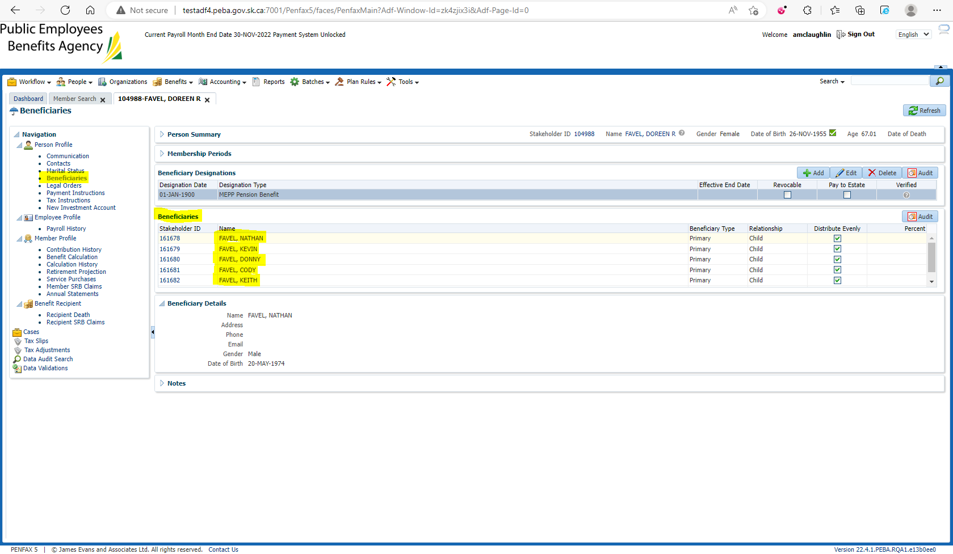

Pension amount is $459.09 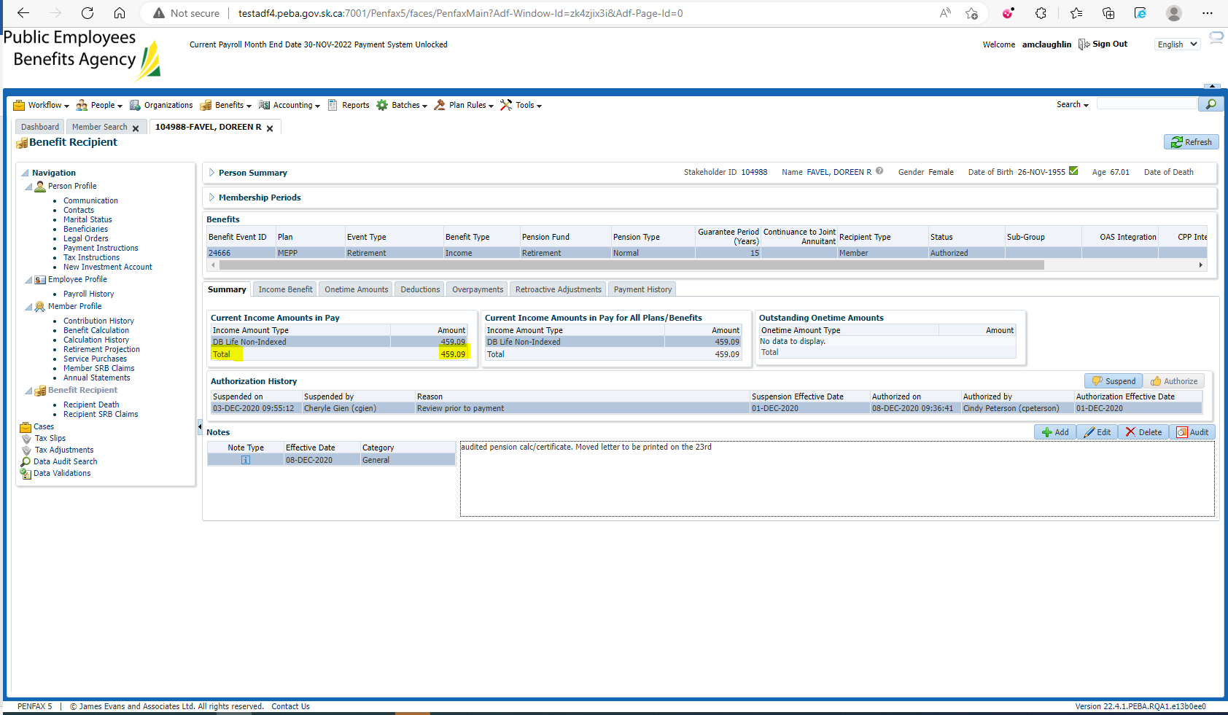

Enter Death Date 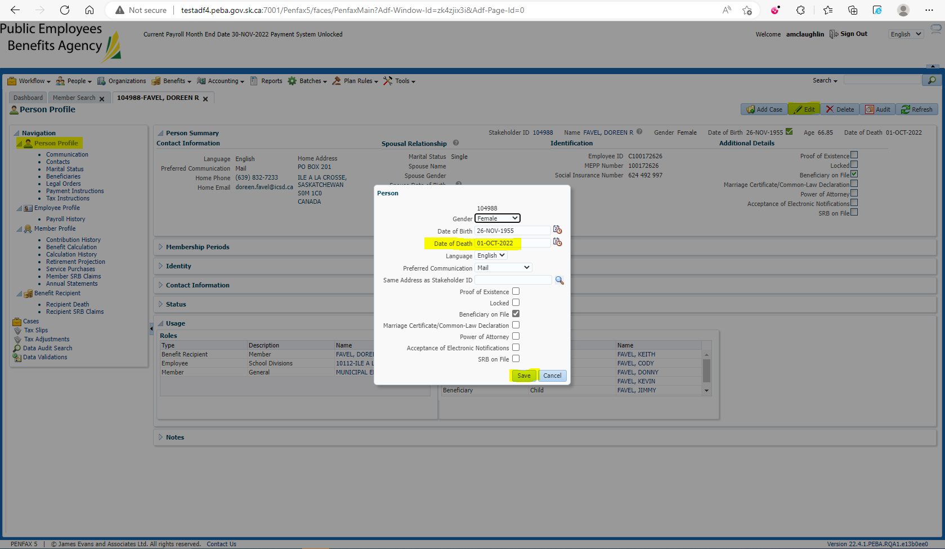 Add the beneficiaries to the Benefit Recipients in the Benefit Event effective 1st day of month after death 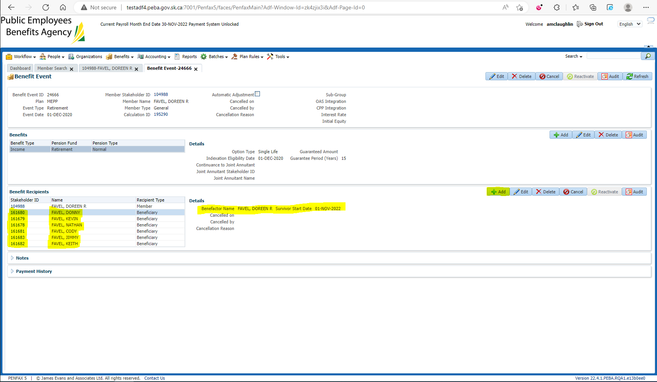

Open the Death Calc 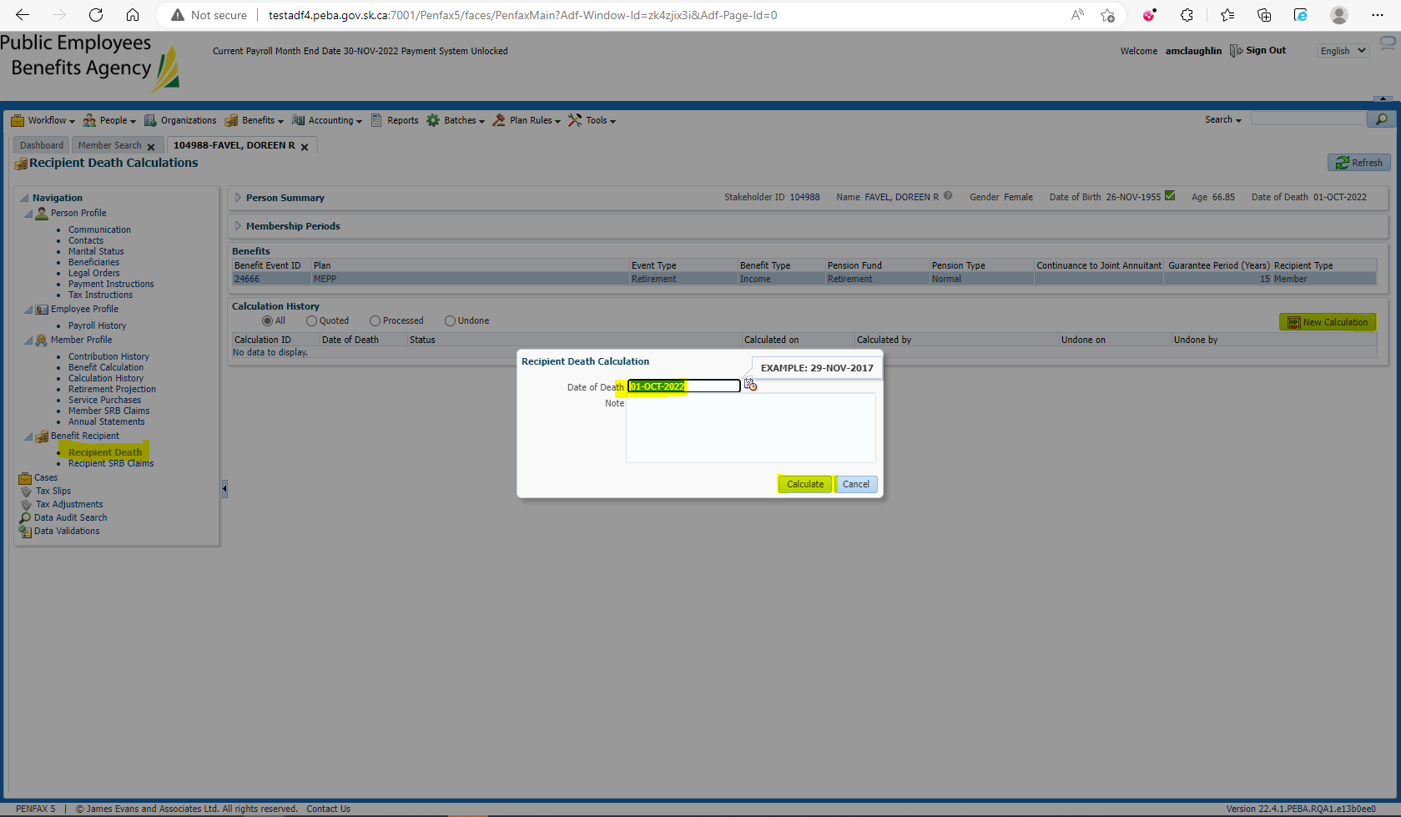

Process x2 and Process Recipient for each beneficiary 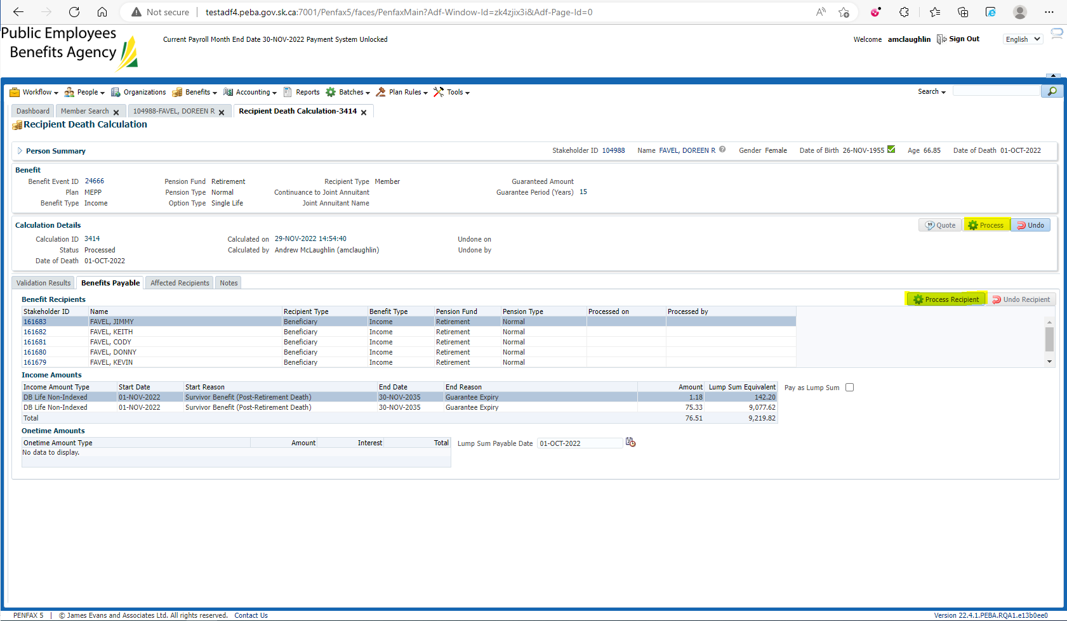

Verify under the beneficiaries’ Benefit Recipient that the income benefit is correctly divided 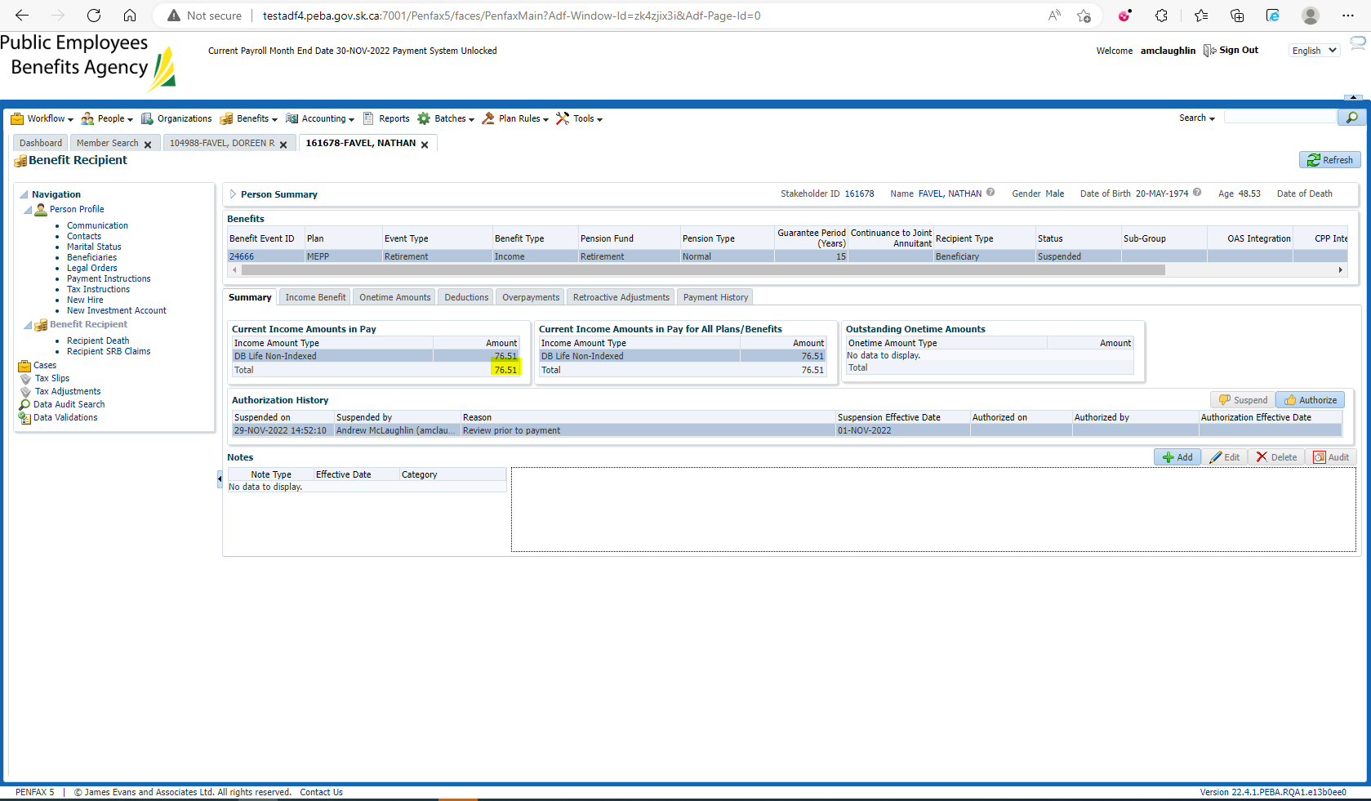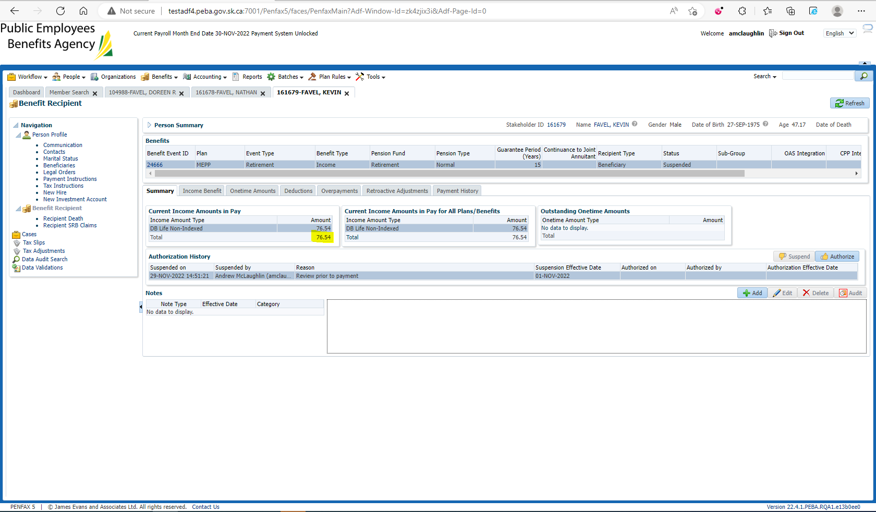 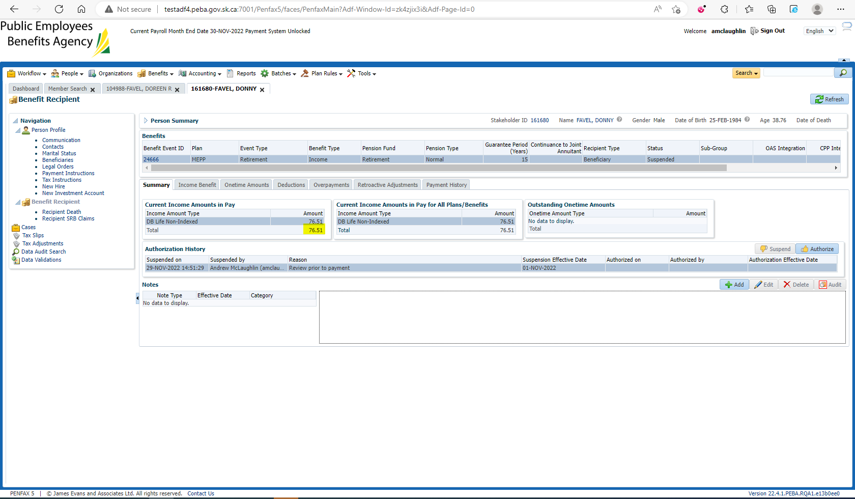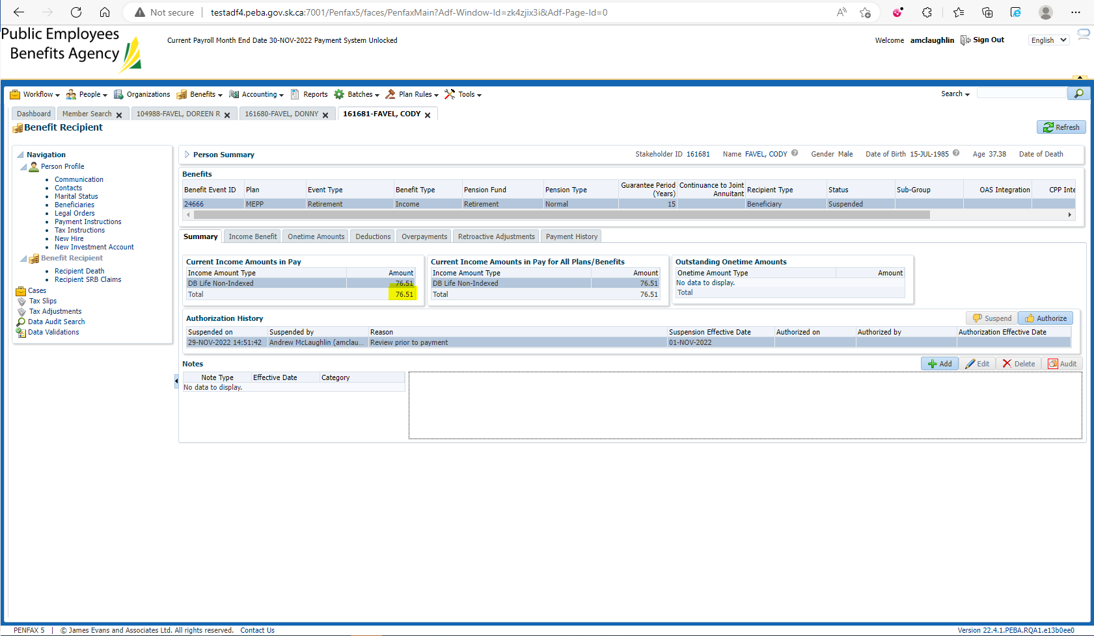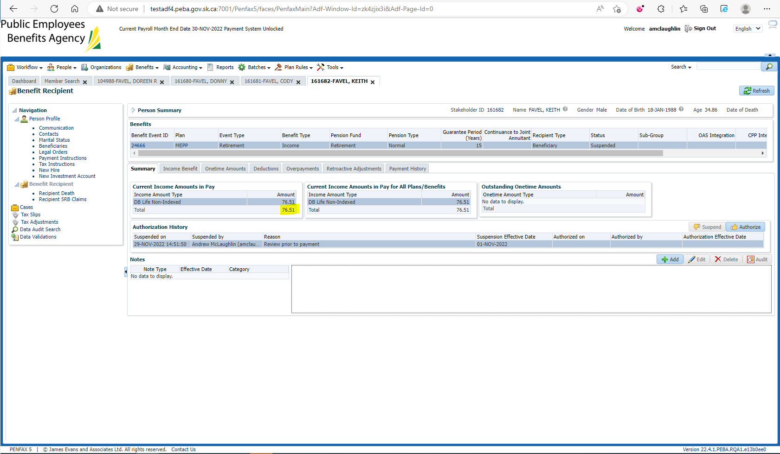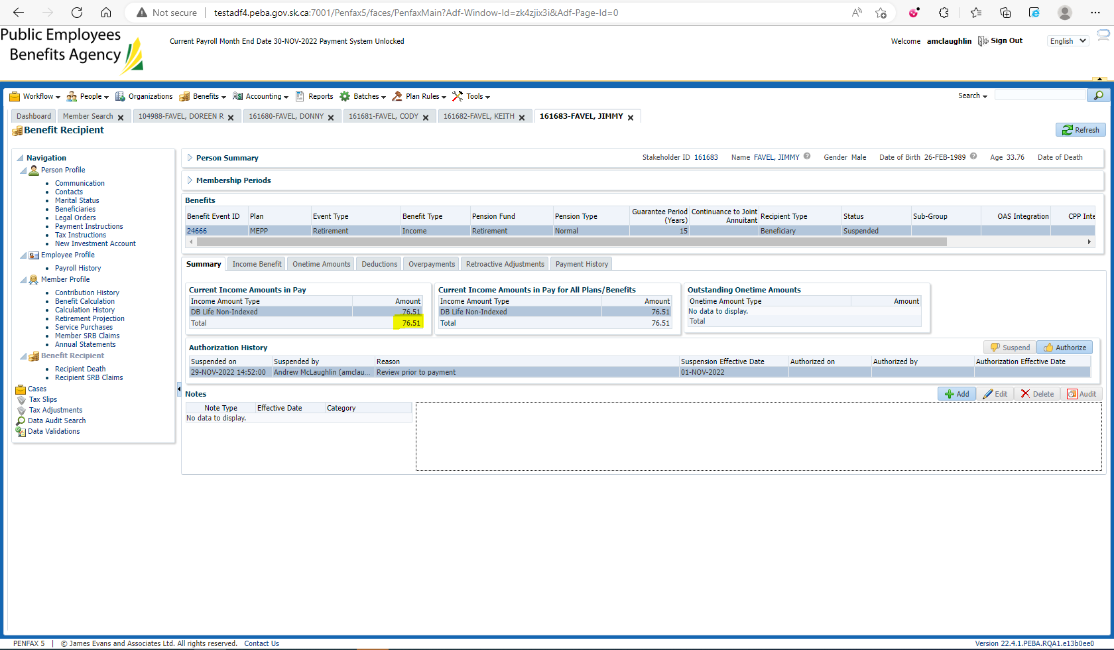

Each member gets $76.51 + $76.54 + $76.51 + $76.51 + $76.51 + $76.51 = $459.09